**Kaplan-Meier Curves**

**Macro Name:** KM_PLOT

**Created Date/Author:** Oct. 5, 2012/ Dana Nickleach

**Last Update Date/Person**: March, 2017/Yuan Liu

**Current Version:** V23

**Working Environment:** SAS 9.4 English version

**Contact:** Dr. Yuan Liu [yliu31@emory.edu](mailto:yliu31@emory.edu)

**Purpose:** To produce one or more Kaplan-Meier plots along with summary statistic tables. Multiple plots can be created using different data sets, outcomes, and strata variables with one macro call. A plot will be produced for each combination of input parameters.

**Notes:** The macro "PLSurvivalTemp V5.sas" is required.

**Citation:** This Macro was created by the Biostatistics and Bioinformatics Share Resource in Winship Cancer Center at Emory University. Free Download at https://bbisr.winship.emory.edu/.

**Parameters:**

|  |  |  |
| --- | --- | --- |
| **Macro variable** | **Description** | **Required** |
| DSN | The name of the data sets to be analyzed separated by spaces. | Yes |
| EVENTS | List of time to event outcome variables separated by spaces. | Yes |
| CENSORS | List of censoring indicator variables separated by spaces. The order must correspond to the order of the EVENTS list. Values of 0 indicate censored observations. | Yes |
| GRPLIST | List of variables to use as strata separated by spaces. A separate plot will be produced for each strata variable. If no variables are specified then survival curves for the whole sample will be produced. | No |
| STRATA2 | A second variable to stratify on in conjunction with the first. The plots will be run using two strata variables in one plot. Note that if you specified multiple variables in GRPLIST then the analysis will be run once for each variable in GRPLIST stratified on both that variable and the variable in STRATA2 every time. This should be empty if GRPLIST is empty. | No |
| WEIGHT | The name of the weight variable to be used in the WEIGHT statement. The weight should be appropriately normalized beforehand. | No |
| TITLE | Title for the plot in quotes or set to DSNLABEL (no quotes) in order to title each plot with the label of the data set used for the plot. If there is no data set label available then the data set name will be used. | No |
| ENTRYTITLE | Specification for entrytitle (plot title). The actual text of the title should be in quotes, but other text can be included as well. For example, entrytitle = HALIGN=LEFT "A" will left align the title "A". The SAS default title will be used if this is not specified. Note that this differs from the TITLE parameter in that the ENTRYTITLE appears on the plot space, whereas TITLE appears above the plot space. | No |
| SUBTITLE | The second title after entrytitle. When ATRISK = T, subtitle will appear. to suppress the title use subtitle = "" | No |
| XLAB | Customize the label for x-axis. Default value will be used when setting XLAB =, | no |
| YLAB | Customize the label for y-axis. Default value will be used when setting YLAB =, | no |
| PAIRWISE | Set to T to request a table of pairwise comparisons. The default value is F. This option may not work well with WEIGHT statement. | No |
| TABLE | Set to T to request a table with N, event, censor, median survival and its 95% CI. The default is F. | No |
| TIMELIST | List of time points separated by spaces at which survival estimates and 95% CI are reported in a table. Note that this is currently only set up to work with one strata variable. | No |
| UNIT | Text for unit of time for survival as it appears in the data, i.e. Yr, Mo, etc. to be used in the table header for time point estimates. This is only necessary if TIMELIST was specified. | Yes, if TIMELIST=T, TABLE=T, and JOIN=T |
| JOIN | Set to T to join median survival estimates and survival point estimates into one table. This is F by default. Note that this is not set up to work when STRATA2 is specified. Set to F when TIMELIST is empty. | No |
| PLOT | Set to F to suppress the KM plot. The default is T. | No |
| XMAX | Maximum x-axis value to display. By default the maximum time available in the data will be used. | No |
| YMIN | Minimum y-axis value to display. The default is 0. | No |
| XTICK | Specify x-axis tick values to display. By default the automatic even space tick values will be used. the maximum tick value should be greater than the value of XMAX. Example of useage: XTICK = (0 6 12 18 24 30 36). | No |
| ATRISK | Set up to T to generate number of subject at risk at x-axis tick values or default tick values. | No |
| DOC | Set to F to suppress creation of the RTF file. The default value is T. | No |
| OUTPATH | File path for output to be stored. | Yes |
| FNAME | File name for output document. | Yes |
| STYLE | The name of the style template to use for the document. | No |
| TOC | Label for outer item in the table of contents in quotes. If an argument is provided then a table of contents will be generated. By default a table of contents is not generated. This will only have an effect when DOC=T or this macro is called within an RTF statement using the CONTENTS=YES TOC_DATA options. Once you open the resulting document in Word, hit CTRL+A and then F9 to update the TOC. | No |
| NONCENSORED | Remove the censor indicator from the KM plot. The default value is F. This is useful when sample size is large. | No |
| TESTNM | Quoted text to specify the name of test used for p-value | No |
| TESTP | The p-value from TESTNM. TESTNM and TESTP could be useful when dealing with weighted or matched data. | No |
| FAILURE | Plot failure curve (1- survival). Default = F, still under development | No |
| DEBUG | Set to T to run in debug mode. Work datasets will not be deleted in debug mode. This is useful if you are editing the code or want to further manipulate the resulting data sets. The default value is F. | No |

**Usage Example:**

**DATA** analysis;

input id os_censor Sex $ Age duration os progress $ trt $;

LABEL os = 'Overall Survival (months)'

progress = 'Progression'

trt = 'Treatment'

duration = 'Duration of Radiation';

DATALINES;

1 1 M 40 44 20 No B

2 1 F 45 46 16 Yes A

3 1 F 40 32 20 No B

4 1 F 47 32 23 No B

5 0 M 41 25 22 No B

6 1 M 54 35 13 No B

7 1 M 48 50 9 Yes A

8 1 M 36 33 12 Yes B

9 0 F 49 51 8 Yes A

10 1 M 49 52 10 Yes A

11 1 M 44 35 12 No A

12 1 M 49 50 8 Yes A

13 1 M 44 44 14 Yes A

14 1 M 50 31 10 Yes A

15 1 M 53 40 15 No B

16 0 M 52 29 20 Yes B

17 1 F 46 45 5 Yes A

18 1 F 37 44 11 Yes A

19 1 M 49 46 13 No B

20 1 M 42 31 11 No A

;

%km_plot(dsn=analysis,

events=os,

censors=os_censor,

grplist=trt,

title='Survival Curves by Treatment',

timelist=12,

unit=Mo,

join=T,

plot=T,

table=T,

OUTPATH=C:\Documents and Settings\User\My Documents\

FNAME=Figure 1 KM Curves);

**Summary Table Example:**

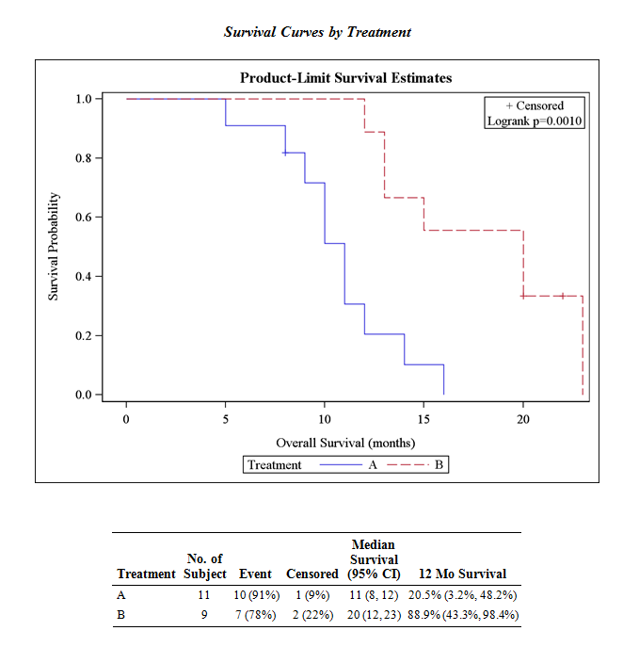

**Permission:**

Permission is hereby granted, free of charge, to any person obtaining a copy of this software and associated documentation files (the "Software"), to deal in the Software without restriction, including without limitation the rights to use, copy, modify, merge, publish, distribute, sublicense, and/or sell copies of the Software, and to permit persons to whom the Software is furnished to do so, subject to the following conditions:   
  
The above copyright notice and this permission notice shall be included in all copies or substantial portions of the Software.  
  
THE SOFTWARE IS PROVIDED "AS IS", WITHOUT WARRANTY OF ANY KIND, EXPRESS OR IMPLIED, INCLUDING BUT NOT LIMITED TO THE WARRANTIES OF MERCHANTABILITY, FITNESS FOR A PARTICULAR PURPOSE AND NONINFRINGEMENT. IN NO EVENT SHALL THE AUTHORS OR COPYRIGHT HOLDERS BE LIABLE FOR ANY CLAIM, DAMAGES OR OTHER LIABILITY, WHETHER IN AN ACTION OF CONTRACT, TORT OR OTHERWISE, ARISING FROM, OUT OF OR IN CONNECTION WITH THE SOFTWARE OR THE USE OR OTHER DEALINGS IN THE SOFTWARE.

**Log of Updates:**

|  |  |  |  |
| --- | --- | --- | --- |
| **Date** | **By** | **Description** | **Version** |
| 11/1/2012 | Dana Nickleach (dnickle@emory.edu) | Added STRATA2 and PAIRWISE parameters. | V2 |
| 11/28/2012 | Dana Nickleach (dnickle@emory.edu) | Added TIMELIST and PLOT parameters. | V3 |
| 12/17/2012 | Sungjin Kim ([skim61@emory.edu](mailto:skim61@emory.edu)) | Added Table with N, event, censor, median survival and its 95% CI under the plot. | V4 |
| 2/1/2013 | Dana Nickleach (dnickle@emory.edu) | Fixed error in reporting median table and made modifications, adjusted formats in point estimate table, fixed repeating title issue, and added event label to point estimate table. | V5 |
| 3/1/2013 | Dana Nickleach (dnickle@emory.edu) | Removed vertical frames from tables. | V6 |
| 3/26/2013 | Dana Nickleach (dnickle@emory.edu) | Added xMax parameter. | V7 |
| 4/16/2013 | Dana Nickleach (dnickle@emory.edu) | Declared macro variables as local so they will not interfere with nested macro calls and added DEBUG parameter. | V8 |
| 4/24/2013 | Dana Nickleach (dnickle@emory.edu) | Set up to handle more than one data set, fixed sorting issue in time point estimate table, and added DSNLABEL option to TITLE parameter. | V9 |
| 5/17/2013 | Dana Nickleach (dnickle@emory.edu) | Fixed parsing of data set names when there are periods, combined survival rate estimates with 95% CI and replaced missing values with NA. | V10 |
| 5/21/2013 | Dana Nickleach (dnickle@emory.edu) | Modified so that tables will be produced when no strata are used. | V11 |
| 5/28/2013 | Dana Nickleach (dnickle@emory.edu) | Added DOC, OUTPATH, FNAME, and STYLE parameters. Note that an RTF document will now be produced by the macro. | V12 |
| 6/20/2013 | Dana Nickleach (dnickle@emory.edu) | Added JOIN and UNIT parameters. | V13 |
| 9/11/2013 | Dana Nickleach (dnickle@emory.edu) | Added %QUOTE function in some inequalities to prevent errors. | V14 |
| 12/12/2013 | Dana Nickleach (dnickle@emory.edu) | Added some checks for errors in parameters. | V15 |
| 12/18/13 | Dana Nickleach (dnickle@emory.edu) | Fixed so that it can correctly handle formatted character GROUP or STRATA2 variables in the pairwise difference table. | V16 |
| 5/6/14 | Dana Nickleach (dnickle@emory.edu) | Added WEIGHT parameter. | V17 |
| 7/16/14 | Dana Nickleach (dnickle@emory.edu) | Modified so that PAIRWISE=T can be used without STRATA2. Modified so that if DOC=F page breaks are still inserted in the correct places if the RTF destination is open. | V18 |
| 8/11/14 | Dana Nickleach (dnickle@emory.edu) | Added TOC parameter. | V19 |
| 9/2/14 | Dana Nickleach (dnickle@emory.edu) | Added ENTRYTITLE parameter. | V20 |
| 10/22/14 | Yuan Liu ([yliu31@emory.edu](mailto:yliu31@emory.edu)) | Added parameters SUBTITLE, XLAB, YLAB, XTICK, and ATRISK | V21 |
| 1/14/15 | Yuan Liu | Added parameter NONCENSORED | V22 |
| 3/17/17 | Yuan Liu | Added YMIN, TESTNM, TESTP. And modify WEIGHT | V23 |